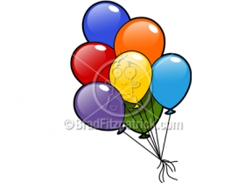
BALLOON RACERS

A force is a push or a pull on an object. These pushes and pulls act upon an object, causing it to move. Other forces cause a moving object to slow down, and eventually stop. When a soccer player kicks a soccer ball he is using a force to move it down the field. The grass and the soccer ball rubbing against each other is a force that will cause the ball to slow down and then stop.
MATERIALS
- String
- Balloon
- ½ of a plastic drinking straw
- Masking tape
- Measuring tape
PROCEDURE
- In groups, blow up the balloon. Use the measuring tape to measure how big around the balloon is. Make sure one member of the group is holding the balloon closed so no air escapes.
- Record how big the balloon is in the table below.
- Tape the drinking straw on the balloon with the masking tape.
- Put one end of the string through the drinking straw. Release the balloon and record how far it travels in the table.
HYPOTHESIS: ____________________________________________________________________________________________________________________________________________________________________________________________________________________________________________________________________________________________________________________________________________________________________________________________________

DATA
GROUP | SIZE | DISTANCE

CONCLUSION
- Was your hypothesis correct? Why or why not? ____________________________________________________________________________________________________________________________________________________________________________________________________________________________________________________________________________________________________________________________________________________________________
- Did larger or smaller balloons travel further? Why?
____________________________________________________________________________________________________________________________________________________________________________________________________________________________________________________________________________________________________________________________________________________________________
3) What would you test if you could repeat the experiment? ____________________________________________________________________________________________________________________________________________________________________________________________________________________________________________________________________________________________________________________________________________________________________

